**CIS 202-60 Databases Semester Project – The Dolphin Inn Database**

Josh Staples

St. Clair County Community College

CIS 202-60: Databases

Professor Christopher Heiden

May 3, 2021

Table of Contents

Title Page1

Table of Contents2

Executive Summary3

Data Dictionary4-5

Relationships6

Test Dataset7

User Documentation8-11

**Executive Summary**

The purpose of The Dolphin Inn Workforce Database is to ensure that employers and current employees of the establishment are able to register new visitors and create reservations to better track travelers coming and going quickly, efficiently, and effectively.

As it stands, especially with the hospitality business, there are many faces that an employee sees working at the front desk and taking reservations, although sometimes reservations are hard to manage with a mostly or entirely manual system. This problem is magnified when considering how that information has to be used for several different purposes, therefore that’s the problem that this database seeks to solve.

The way that the database works is fairly simple – basic information is taken in such as the customer’s first and last name, email address, phone number, and travel times, and from there the hassle is out of their hands. From there, the employee simply has to input that information into the database and the database will take the information and maintain it, while also using it as needed. Having a centralized record database is additionally supportive due to the ability to maintain records for long periods of time instead of having to overwrite or erase them after a period of time.

Digital databases are mandatory for an environment such as that of the hospitality business because so much goes on that it’s hard to maintain with just one or two minds. Human nature causes people to forget, but that’s manageable in the digital world where the capabilities of recording information to be stored in bulk is much more significant than it is setting up a manual sorting system, much less a database.

Being able to reduce the time that the customer and the employee focus on one moment of setting up a reservation is vital because both the employee and customer likely have other responsibilities to be attending too, and so a system prone to malfunction or a system that is inefficient simply won’t suffice in this sort of scenario. Especially being in a tourist haven such as Florida, during tourist season there are large quantities of reservations trying to be arranged and therefore there is no time to waste.

**Data Dictionary**

|  |  |  |
| --- | --- | --- |
| **Reservations** | | |
| Column | Data Type | Size |
| ***ResID*** | Autonumber | 10 |
| FName | Short Text | 20 |
| LName | Short Text | 20 |
| Email | Short Text | 255 |
| Phone | Short Text | 9 |
| Start Date | Date/Time | N/A |
| End Date | Date/Time | N/A |
| Comments | Long Text | N/A |

|  |  |  |
| --- | --- | --- |
| **Room** | | |
| Column | Data Type | Size |
| ***RoomNum*** | Number | 2 |
| DateMaint | Date/Time | N/A |
| ScheduledMaint | Date/Time | N/A |
| Comments | Long Text | N/A |

|  |  |  |
| --- | --- | --- |
| **Rentals** | | |
| Column | Data Type | Size |
| ***RentalID*** | Autonumber | 10 |
| Name | Short Text | 20 |
| Cost | Currency | 7 |
| ResID | Number | 10 |

|  |  |  |
| --- | --- | --- |
| **Staff** | | |
| Column | Data Type | Size |
| ***StaffID*** | Autonumber | 10 |
| FName | Short Text | 20 |
| LName | Short Text | 20 |
| Email | Short Text | 20 |
| Phone | Short Text | 9 |
| Address | Short Text | 50 |
| EmployedDate | Date/Time | N/A |
| Salary | Currency | 10 |

|  |  |  |
| --- | --- | --- |
| **Maintenance** | | |
| Columns | Data Type | Size |
| ***MaintID*** | Autonumber | 10 |
| MaintDate | Date/Time | N/A |
| StartTime | Date/Time | N/A |
| FinishTime | Date/Time | N/A |
| StaffID | Number | 10 |
| RoomNum | Number | 2 |
| Comments | Long Text | N/A |

**Relationships**

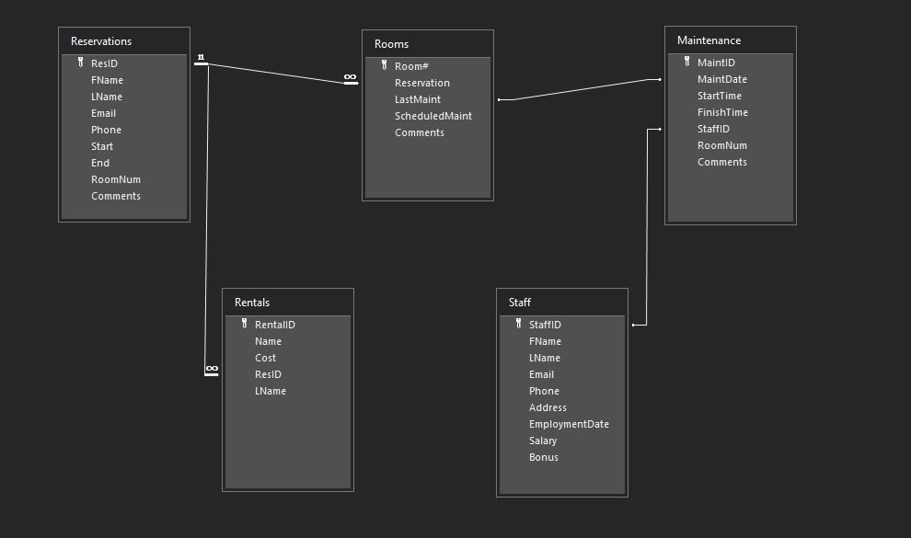

**User Documentation**

# **The Dolphin Inn Workforce Database**

# ***Quick Start Guide***

All the boxes on the screen might look daunting at first, but don’t worry! All *you* need to do is put in the information! It couldn’t be any simpler.

Different parts of this guide are relevant to different parts of the database, and therefore it’s broken up into 4 sections.

* Reservations
* Rentals
* Maintenance
* Searching for Data

# Reservations

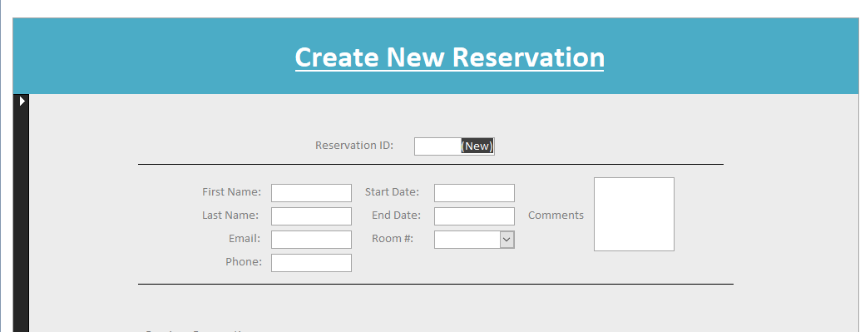

When you’re creating a reservation, it’s a really simply feat. The **Reservation ID** fills itself in and is just there to look up information. When creating a reservation, all you need to do is fill in the boxes with the appropriate information and you’ll be on your way!

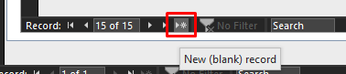

After your first record is filled out, simply click the **New (blank record)** button on the bottom of the form to create a new record for the next reservation.

**\*\*Note**: Do be mindful that the fields that have special formats (phone, start date, end date) have input masks so the box will always start filled with underscores. It goes away though, just backspace them away and you should be able to type in there.

# Rentals

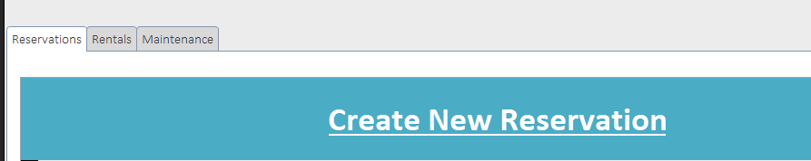To switch to the next tab, click the **Rentals** button above the form and it will switch the form to a new one for rentals only. This is made for renting out any of the other services at the inn, such as bikes.

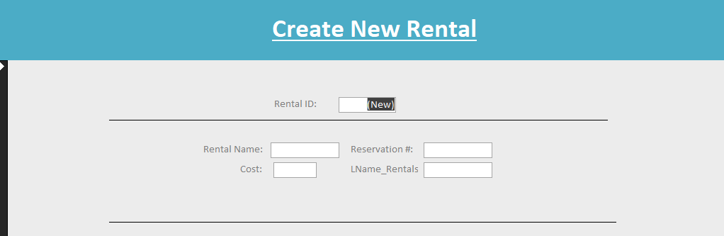

Similarly to the reservations form, all you have to do is fill in the information pertaining to the rental. The **Rental Name** field is the only real outlier, and it is flexible to allow a custom name to be put in for the rental if need be. The only information required for this is a name, cost, reservation number (can be looked up in the reservations form, see bottom), and last name. Aside from different information, it’s much the same.

# Maintenance

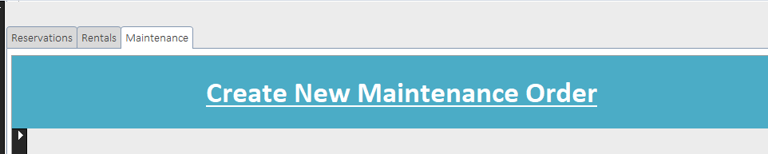

Getting to maintenance orders is easy, simply click the **Maintenance** form at the top of the screen.

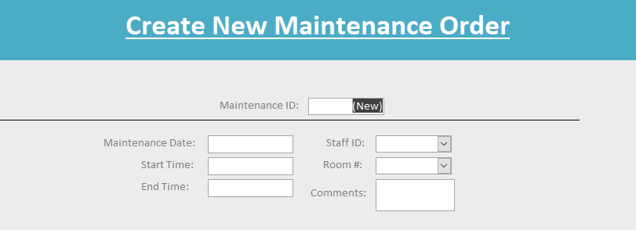

The information is much the same, except it relies on a date, start and end times, a staff id which is has already been put in to the system, a room number, and an optional comment.

Really, the system couldn’t be much simpler. The last thing to consider is possibly one of the most important.

# Searching for Data

Even though it’s slightly more complicated than filling in boxes, searching for data is possibly one of the most important functions because the point of the information being used in a database is to be stored and used; and what good would it be if it didn’t even do that!

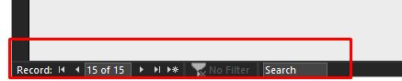

Using the buttons at the bottom of any of the three forms can allow you to go between records that have already been established manually, but you are also able to search for any sort of information that’s necessary. Names? Search it. ID? Search it. Phone Number? You know where this is going. That’s right, search it. Any and all of the information is right at your fingertips, all you have to do is look for it.

# And that’s it!

You didn’t need some sort of hardcore training session for this because it’s just that easy! Now that you know everything you need about the database, why not put it to some use?